# Phase III: Logical Model Design

Automated Scholarship Management System  
Mushirarungu (Student ID: 27380)  
Adventist University of Central Africa  
  
April 20, 2025

## Introduction

This document details the Logical Model Design phase for the Automated Scholarship Management System, part of the Database Development with PL/SQL (INSY 8311) Capstone Project at AUCA. The goal is to create a logical data model supporting scholarship application, review, and disbursement processes, ensuring data integrity and scalability. This phase defines entities, relationships, and constraints, adhering to 3rd Normal Form (3NF) normalization.

## Entity-Relationship (ER) Model

### Entities and Attributes

The ER model includes:  
• Students: Student_ID (PK, NUMBER), Name (VARCHAR2), GPA (NUMBER, CHECK 0-4).  
• Scholarships: Scholarship_ID (PK, NUMBER), Name (VARCHAR2), Criteria (VARCHAR2).  
• Reviewers: Reviewer_ID (PK, NUMBER), Name (VARCHAR2).  
• Applications: Application_ID (PK, NUMBER), FK Student_ID, FK Scholarship_ID, Date_Submitted (DATE), Status (VARCHAR2).  
• Documents: Document_ID (PK, NUMBER), Application_ID, File_Type (VARCHAR2), Upload_Date (DATE).  
• Admins: Admin_ID (PK, NUMBER), Name (VARCHAR2).  
• Audit_Mirrs: Admin_ID (PK, NUMBER), Name (VARCHAR2).  
• Notifications: Notification_ID (PK, NUMBER), FK Student_ID, Message (VARCHAR2), Date_Sent (DATE), Read_Status (VARCHAR2).

### ER Diagram

The ER diagram below illustrates the relationships and structure of the system:

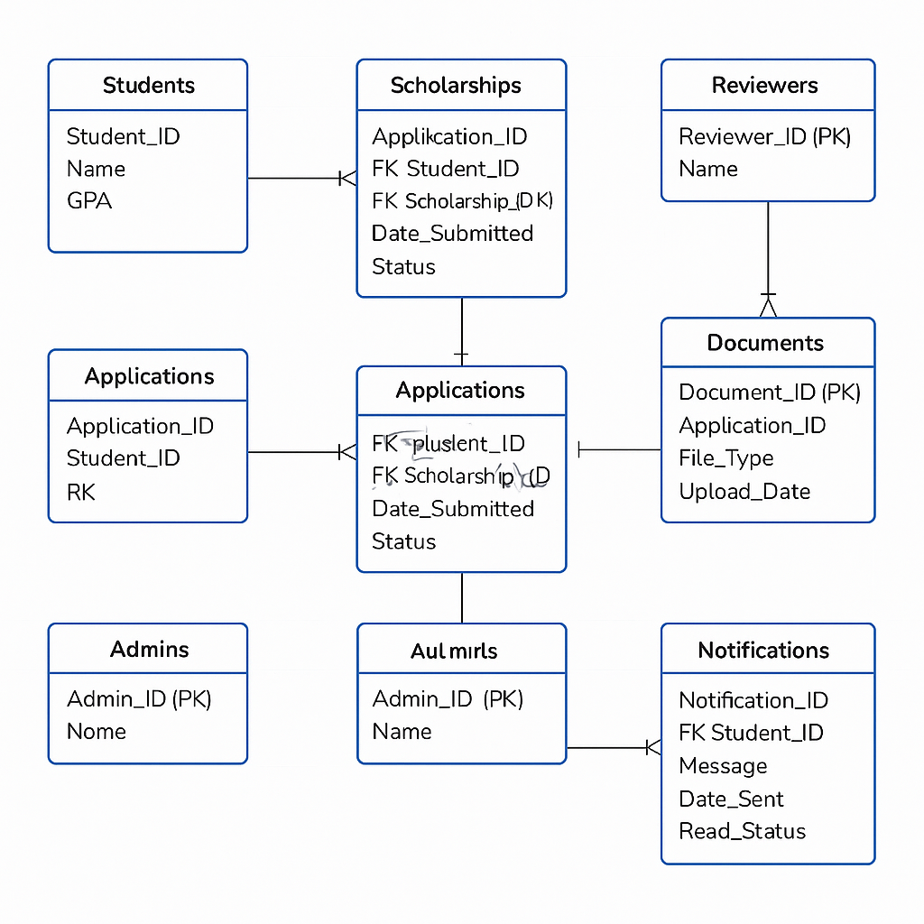

## Relationships and Constraints

### Relationships

Relationships are enforced via:  
• Students to Applications: 1:N via FK Student_ID.  
• Scholarships to Applications: 1:N via FK Scholarship_ID.  
• Applications to Documents: 1:N via Application_ID.  
• Students to Notifications: 1:N via FK Student_ID.  
• Admins to Audit_Mirrs: 1:1 via Admin_ID.

### Constraints

Constraints include:  
• NOT NULL: Name in Students, Scholarships, Reviewers, Admins.  
• CHECK: GPA (0-4) in Students.  
• UNIQUE: Primary keys (e.g., Student_ID).  
• Foreign Keys: Ensure referential integrity.

## Normalization

The design follows 3NF:  
• 1NF: Atomic attributes (e.g., Name).  
• 2NF: No partial dependencies.  
• 3NF: No transitive dependencies (e.g., Audit_Mirrs).

## Conclusion

The logical model supports efficient scholarship management, forming the basis for physical implementation. It ensures data integrity and scalability for real-world use.